|  |  |  |
| --- | --- | --- |
| Key COVID-19 Metrics Summary Callout values Category labels | |  | | --- | | Power BI Desktop | |
| |  |  |  | | --- | --- | --- | | Active cases | 0.037 | 6 | | Case Fatality Rate (CFR) | 0.0061 | 5 | | Deaths | 358 | 4 |   Discharged/Recoveries 55899 2 |  |
| Healthcare workers affected 3659 8   |  |  |  | | --- | --- | --- | | Recovery rate (%) | 0.957 | 3 | | Total case | 58431 | 1 |   Total test conducted 717279 7 |  |

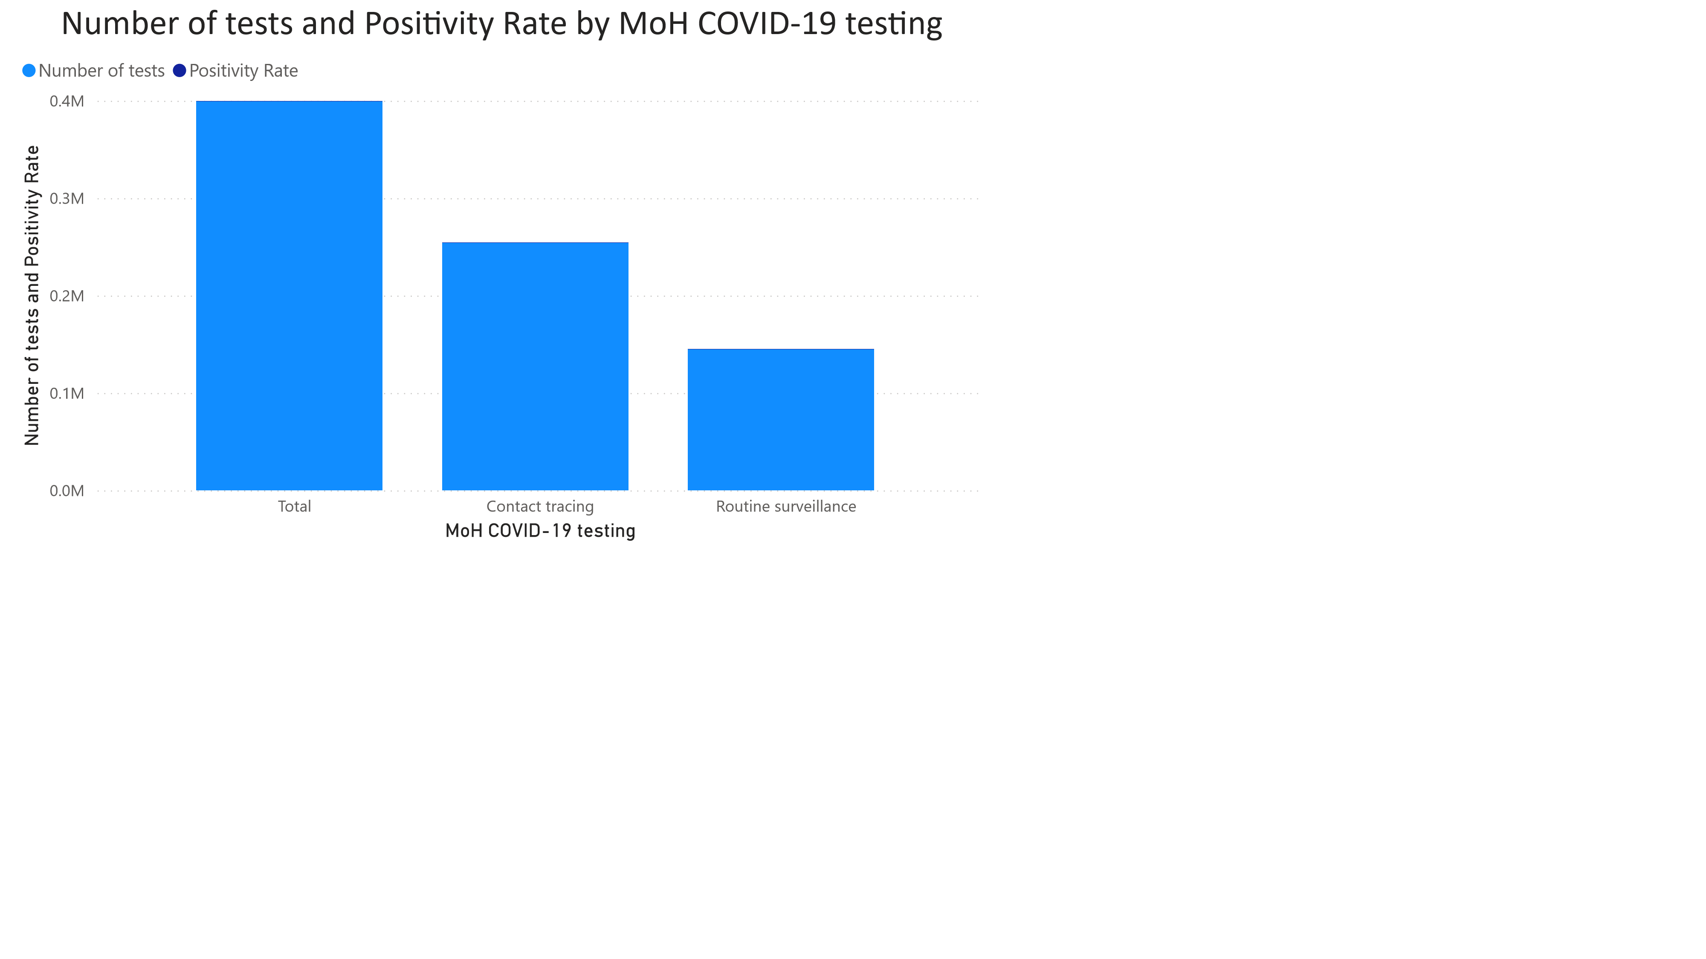

Power BI Desktop

Sum of Number by MoH Staff Category Distribution and Percentage of total

393 (50%)

282 (35.88%)

111 (14.12%)

**MoH Staff Category Distributi…**

Grand total

Senior

Junior

Sum of Number by MoH Staff Sex Distribution and Percentage of total

223 (56.74%)

170 (43.26%)

**MoH Staff Sex Distribution**

Male

Female